**User Interface Design**

Online Book Store

**TEAM ALLIANCE**



**Version I**

Team Members

Jiaxing Lu (liujiaxinq@qq.com)

Kancharla Kiran Reddy ([kiran.kancharla92@gmail.com](mailto:kiran.kancharla92@gmail.com))

Christopher James (cjames1201@my.mwsu.edu)

Azharuddin Mohammed(azharuddinhussaini1989@gmail.com)

Contents

1. Introduction 1

2. User Interface Design 1

3. Description of the User Interface 1

3.1 Screen Images 2

4. References 2

# 1. Introduction

# 2. User Interface Design

The main purpose of the user interface design is to make the user interaction as simple as possible and efficient, in terms of goal accomplishment. The usability influences how the user performs the interaction and helps to improve the aesthetic appeal of the design. The system is created following the design process to balance the technical functionalities and the visual elements.

# 3. Description of the User Interface

The interface planned and to be developed is a mobile interface system for the project. The mobile usage has made people very demanding for mobile interfaces. The interface gives a friendly appeal to the user. There are several interaction screens for interaction with the system. The different screen interfaces are developed to cover all the functionalities of the user needs.

The very first page is a login page interface. The login page displays the application logo and different input fields, buttons to validate and verify the correct users and enable the user for usage of the system. Both the students and professors can login with their credentials. After correct validation and verification the screen navigates to the main page of the application from this page interface then the user can perform his/her task operations. It also allows the users to create a new account if they don’t have an account.

The Signup page is used to create a new account for a user by allowing him to fill the complete details. Once the student logs in to his account he/she can make a new appointment or view the status of his previous appointments. Students can also cancel the scheduled appointments. Once the professor logs in to his account a list of scheduled appointments will be displayed on the screen. Professors can select any one of it and can reject/suggest a appointment.

# 3.1 Screen Images

Figure 3.1 illustrates how the main page for the online book store will be. It has the name of the book store, which is Alliance. The user can see all the kinds of books available in the book store before login.

Once the user clicks on the login it will take him to login page. Similarly, the user can go to cart, settings, comments page or if wants any support he can go to the support page.

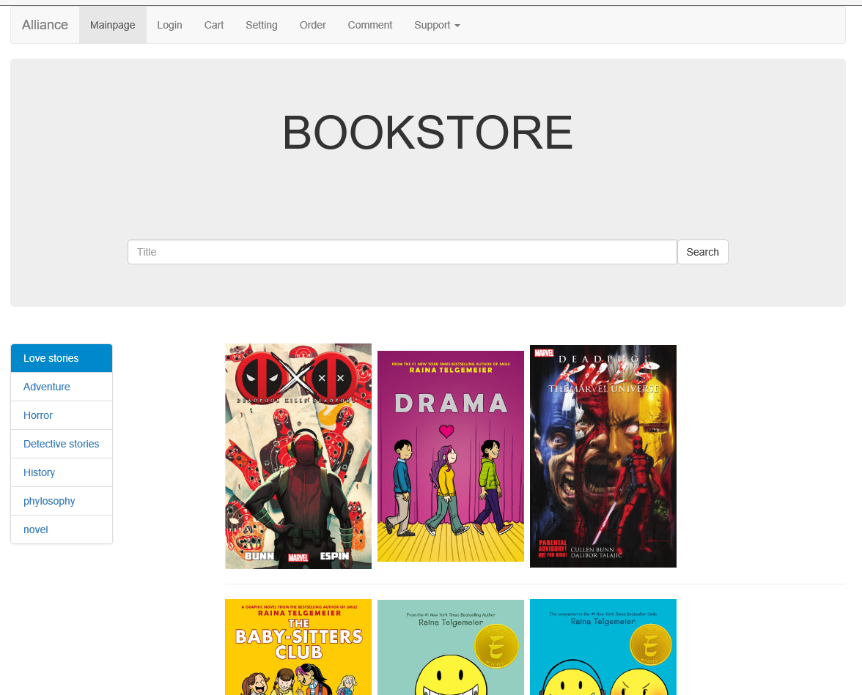

Figure 3.1 Main page of the book store.

As we can see from the figure 3.1 if the user clicks on the login page it will take him to login page which will be like figure 3.2. The user can log in from here and order the book he wants. If the user doesn’t have a user id and password, he can register as a new user can continue shopping. Registration page is shown in figure 3.3

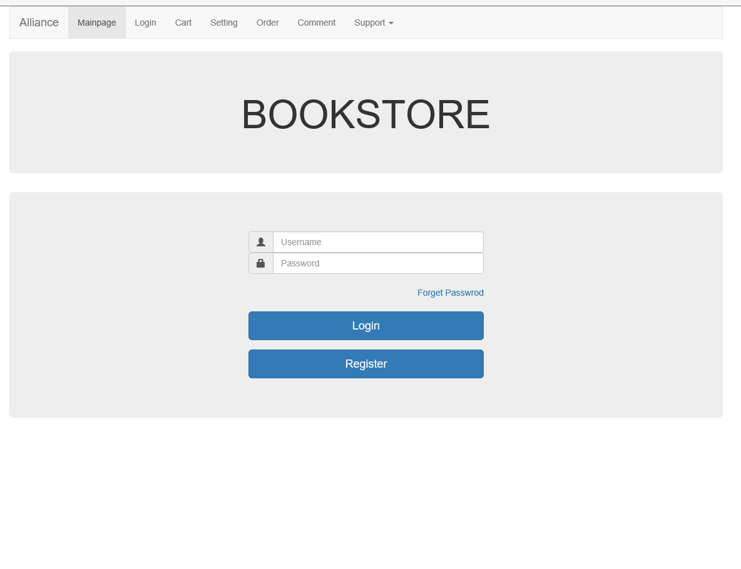

Figure 3.2 Login page

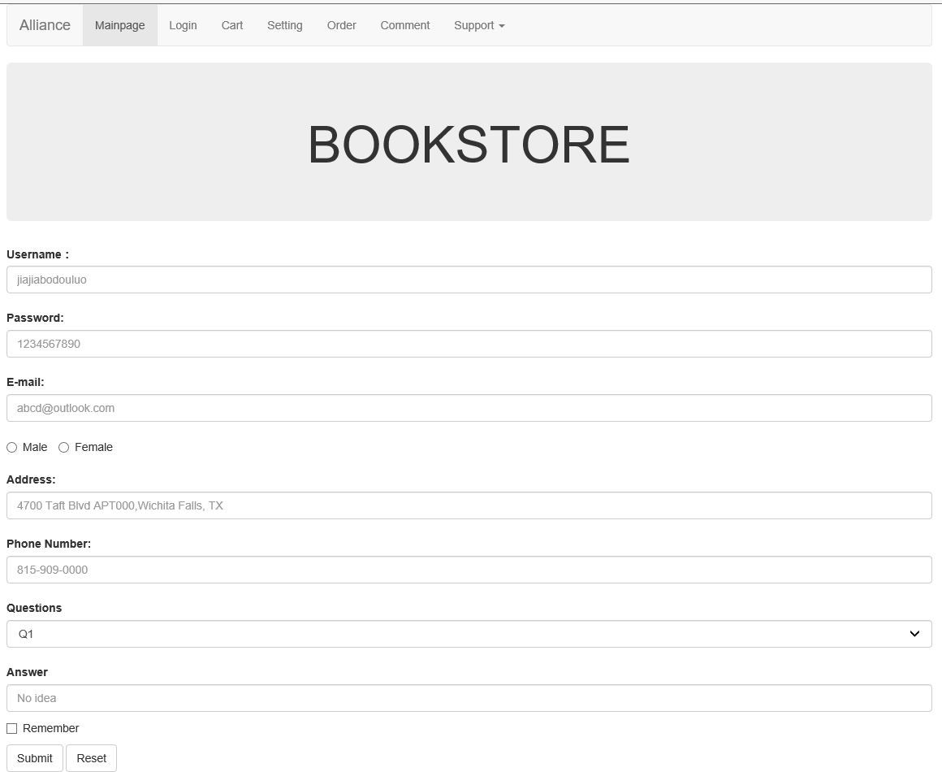

Figure 3.3 Registration page.

Figure 3.4 illustrates how the user can request for a new password if he forgot the password. After selecting the book, the user gets to see all the information about the book which he has selected. It will take him to the book information page which is shown in figure 3.5.

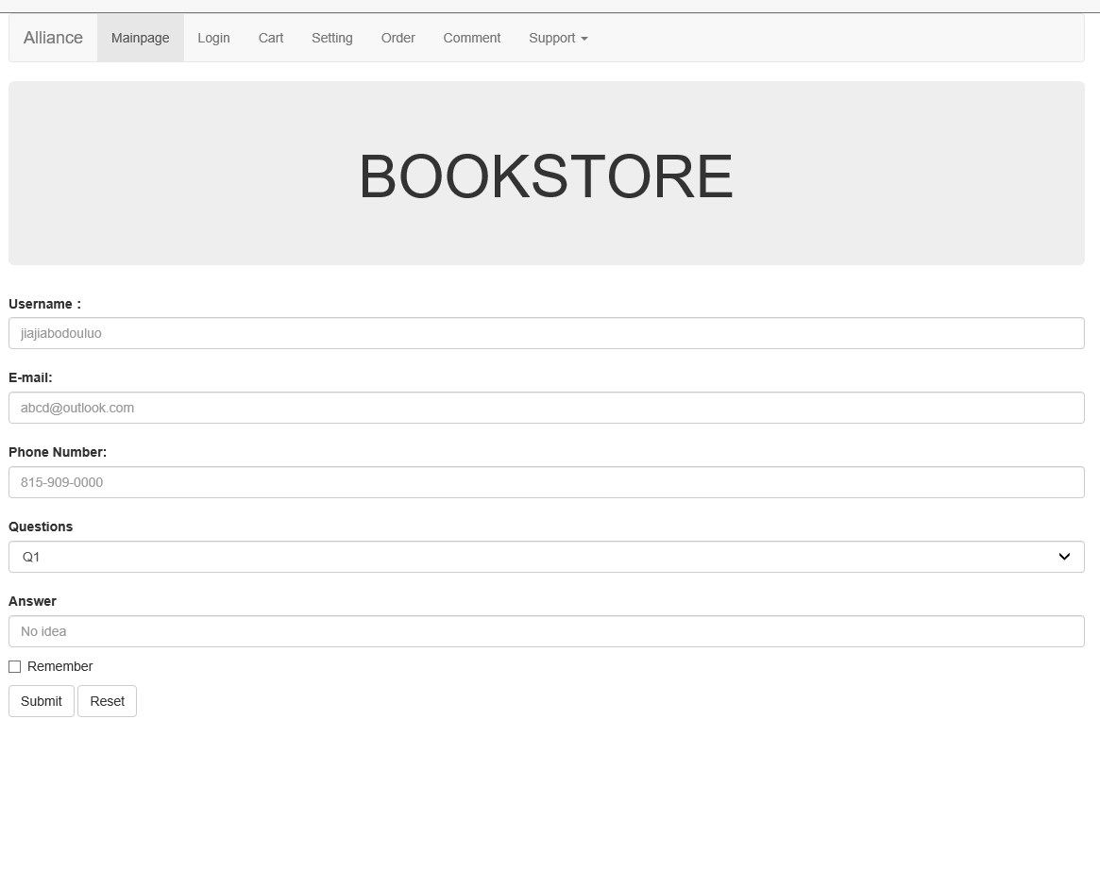

Figure 3.4 Forgot password page

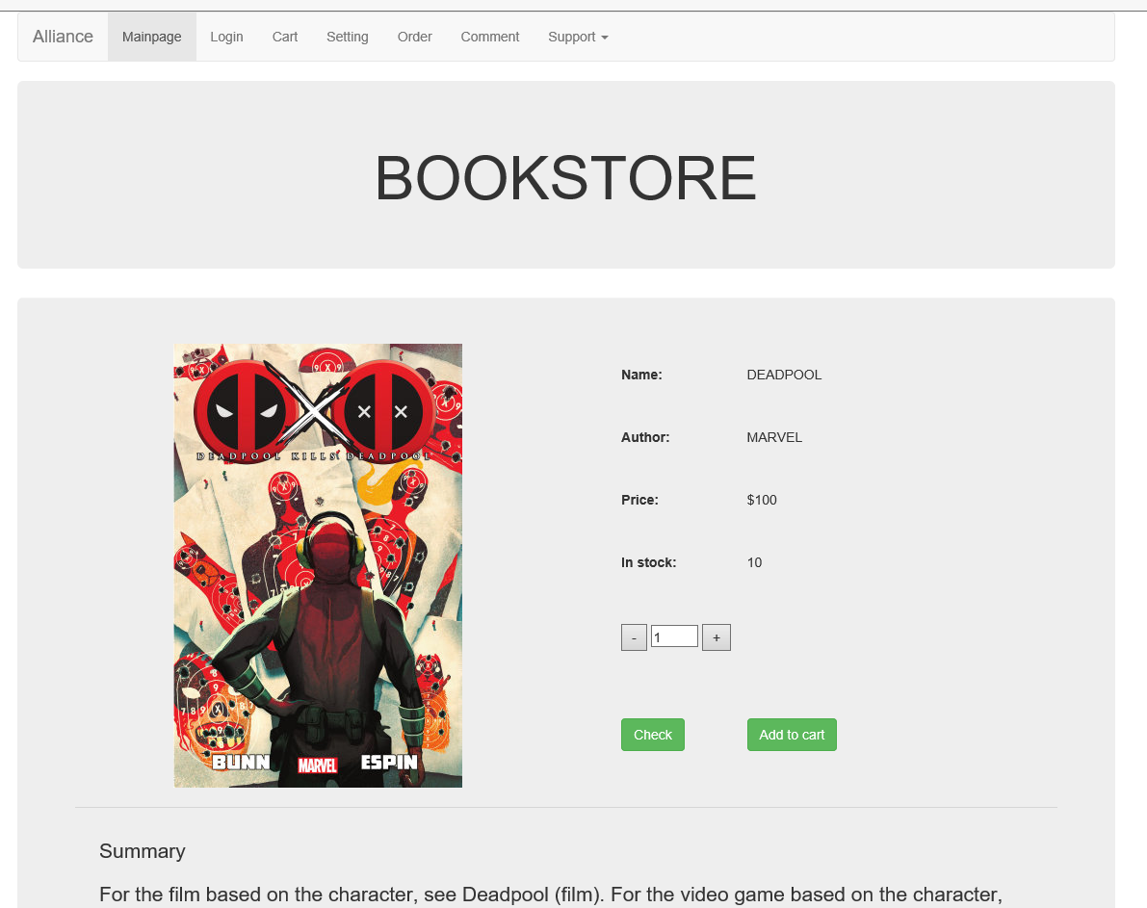

Figure 3.5 Book information page

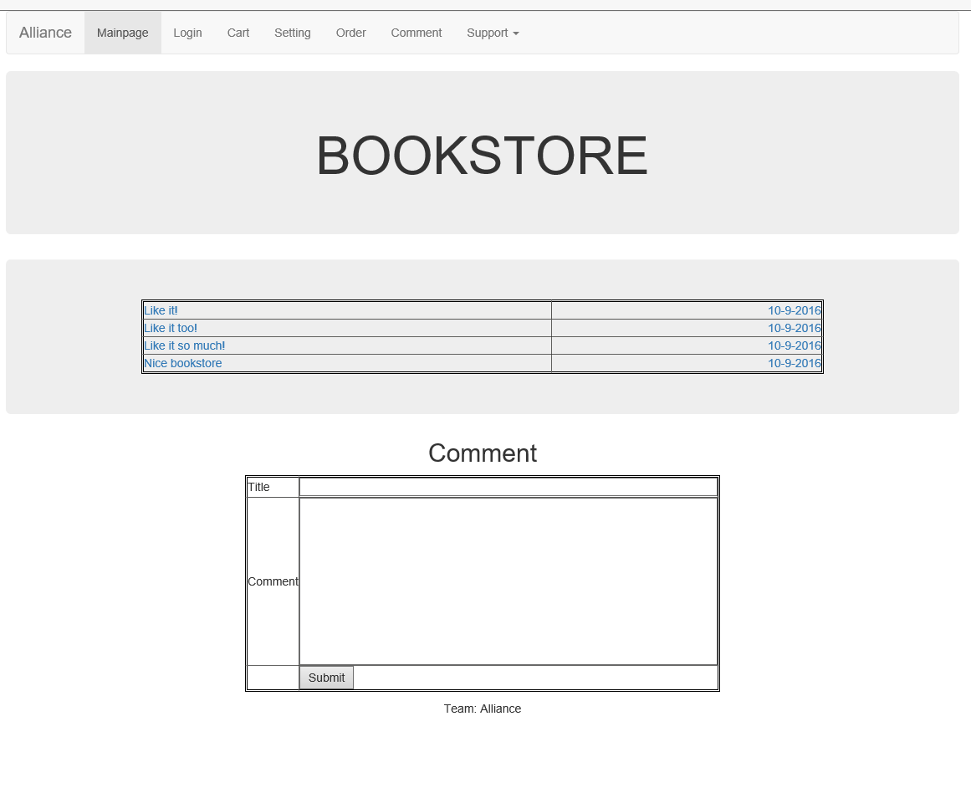

# 4. References

# McGraw, R. J. (2015, june 15). FOXMIS. Retrieved october 27, 2015, from Google: http://community.mis.temple.edu/mis2101sec711summer2015/

* Larman, C., Applying UML and Patterns: Introduction to Object-Oriented Analysis and Design and Iterative Development, 3rdedition (October 2004).
* Sommerville, I., Software Engineering 9th edition book, Pearson (March 2004).